**Assignment: Subqueries**

Brandon Trinkle

Arizona State University

IFT 300

Professor Ashish Gulati

11/12/2024

**Assignment: Subqueries**

1. Write a SELECT statement that returns the same result set as this SELECT statement. Substitute a subquery in a WHERE clause for the inner join. (8 points)

SELECT DISTINCT VendorName

FROM Vendors v

JOIN Invoices i

ON v.VendorID = i.VendorID ORDER BY VendorName;

/*

** Author: Brandon Trinkle

** Course: IFT/300

** SQL Server Version: Microsoft SQL Server 2012 (SP1)

** OS : Windows

** History

** Date Created Comments

** 11/20/2024

*/

SELECT DISTINCT VendorName

FROM Vendors

WHERE VendorID IN (

SELECT VendorID

FROM Invoices

)

ORDER BY VendorName;

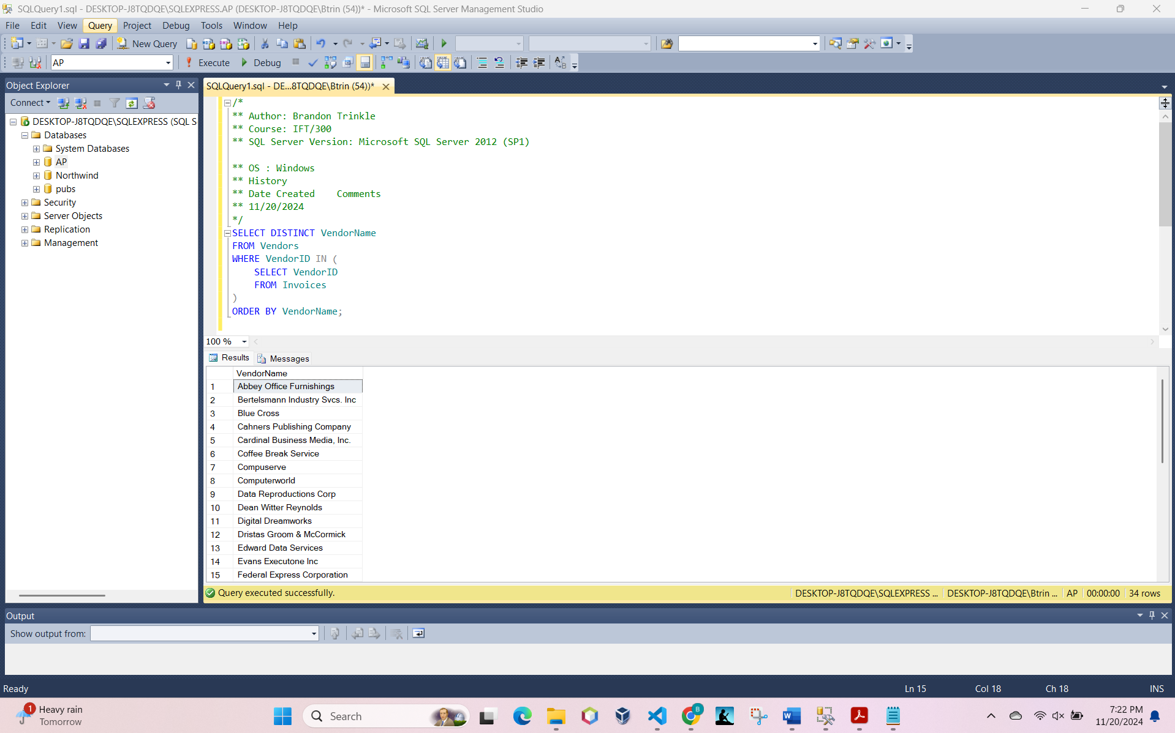

1. Write a SELECT statement that answers this question: Which invoices have a PaymentTotal that’s greater than the average PaymentTotal for all paid invoices? Return the InvoiceNumber and InvoiceTotal for each invoice.

/*

** Author: Brandon Trinkle

** Course: IFT/300

** SQL Server Version: Microsoft SQL Server 2012 (SP1)

** OS : Windows

** History

** Date Created Comments

** 11/20/2024

*/

SELECT InvoiceNumber, InvoiceTotal

FROM Invoices

WHERE PaymentTotal > (

SELECT AVG(PaymentTotal)

FROM Invoices

WHERE PaymentTotal > 0

);

1. Write a SELECT statement that answers this question: Which invoices have a PaymentTotal that’s greater than the median PaymentTotal for all paid invoices?

(The median marks the midpoint in a set of values. In other words, an equal number of values lie above and below the median value.) Return the InvoiceNumber and InvoiceTotal for each invoice.

/*

** Author: Brandon Trinkle

** Course: IFT/300

** SQL Server Version: Microsoft SQL Server 2012 (SP1)

** OS : Windows

** History

** Date Created Comments

** 11/20/2024

*/

WITH RankedPayments AS (

SELECT PaymentTotal,

ROW_NUMBER() OVER (ORDER BY PaymentTotal) AS RowAsc,

ROW_NUMBER() OVER (ORDER BY PaymentTotal DESC) AS RowDesc

FROM Invoices

WHERE PaymentTotal > 0

),

Median AS (

SELECT AVG(PaymentTotal) AS MedianValue

FROM RankedPayments

WHERE RowAsc = RowDesc OR RowAsc + 1 = RowDesc

)

SELECT InvoiceNumber, InvoiceTotal

FROM Invoices

WHERE PaymentTotal > (SELECT MedianValue FROM Median);

